**Content Labeling Technologies Page**

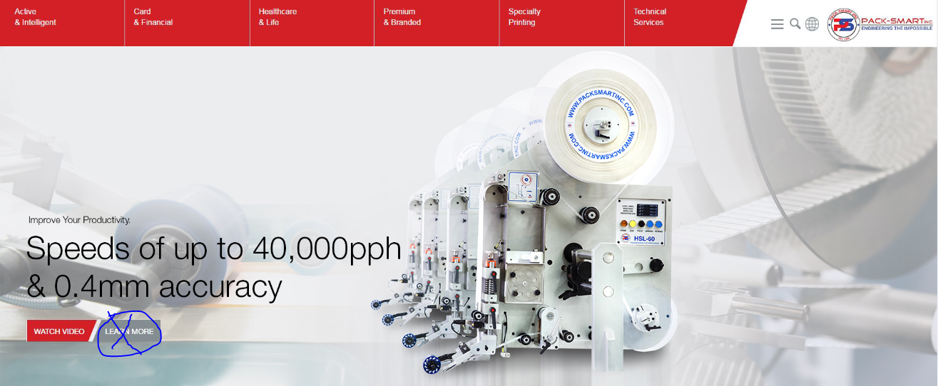

**Slide 1 (NO RED RIBBON)**

*Small Text*: Improve Your Productivity

*Large Text*: Speeds of Up to 40,000pph & 0.4mm Accuracy

*Watch Video (link)*: <https://www.youtube.com/watch?v=I6sk_SC-Bas>

*Learn More*: **NO BUTTON**

**Slide 2 (NO IMAGE PROVIDED YET)**

*Small Text*:

*Large Text*:

*Learn More: Automatically Scroll Down to Labeling Technologies Tiles* (Action when clicked)

**Slide 3 (NO IMAGE PROVIDED YET)**

*Small Text*:

*Large Text*:

*Learn More: Automatically Scroll Down to Labeling Technologies Tiles* (Action when clicked)

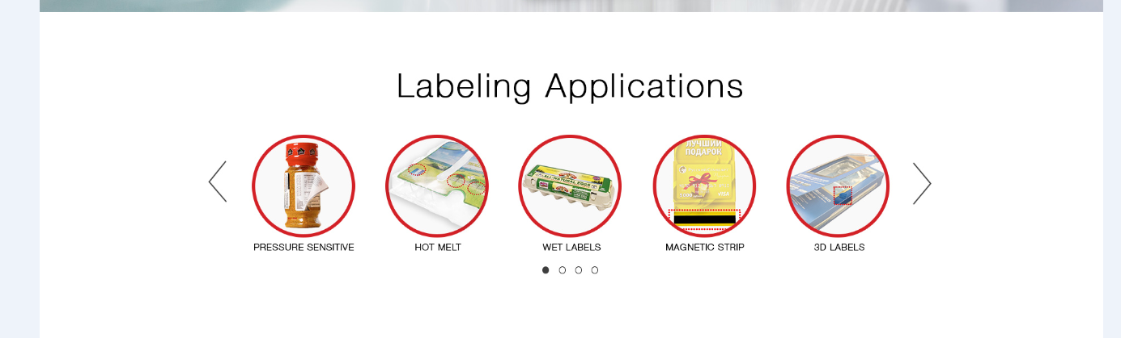

**Functionality of Circle Tabs**:

*Hover*: Zoom in effect

*Click*: Goes to respective page, ex. www.packsmartinc.com/technologies/labeling/hot-melt

**CIRCULAR TILES**: (more will be added later on)

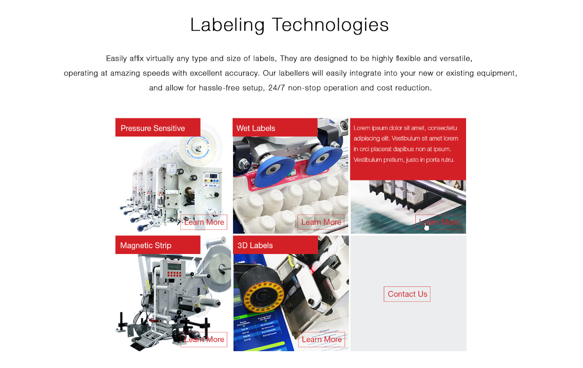

**Title**: Labeling Technologies

**Description**:

Easily affix virtually any type and size of labels, they are designed to be highly flexible and versatile, operating at amazing speeds with excellent accuracy. Our labelers will easily integrate into your new or existing equipment, and allow for hassle-free setup, 24/7 non-stop operation and cost reduction.

**TILES SECTION**: Functionality & Description

*Hover over tile*: Description Slides Down Animation

*Hover over button*: changes to a filled red box and font is white.

*Click button*: redirects to ex. www.packsmartinc.com/technologies/labeling/hot-melt

**Pressure Sensitive**

Widely-spread over a broad range of industries, the pressure sensitive labels are easy to handle and apply. From Printable, Piggyback, Scratch-off, Wafer/Clip Seal, Sensormatic, and Checkpoint to Double-sided Clear, we have the technologies to affix them in an amazingly fast and accurate manner, for your

**Hot-Melt Labels**

Characteristic for the Bottling industry, hot melt labels are generally complete wraparound labels on containers made of glass, plastic or metal. We developed high throughput versatile solutions, which can operate with hot glue-, cold glue-, or self-adhesive labels.

**Magnetic Strip**

Magnetic Strip is mainly used in Access Applications, such as Banking or IDs. As a clear example of our flexible design, and even though magnetic strip is not a conventional label, it can easily be applied by our labelling modules with the same high speed and accuracy we provide to all our customers.

**Wet Labels**

Wet label affixing is a more involving process, for which we developed end-to-end comprehensive solutions. You can opt for a minimal solution for affixing labels only, or a completely tailored solution where wet label affixing is just a step of your packaging process.

**3D Labels**

For your individualized requirements, we offer technologies for 3D object affixing, such as Velcro, CD Hub, Felt Pads, and more. You will be amazed by the speed and accuracy of our modules.

**TILE: CONTACT US** (we only have 5 technologies in this labeling family, so we utilize a contact button here) When this button is clicked it will automatically scroll the page down to the Contact form.